Once upon a time in a small town, on a poor street lived a girl whose name was Lili. Lili lived in a house for orphans. She was a very pretty, kind, beautiful, clever, interesting and keen girl. She had only one red old dress and white shoes. She had brown hair, blue eyes and pink lips and she was a very good friend. Lili wanted a beautiful doll with light hair, brown eyes, red lips, a red dress with white dots and red shoes. But she knew that no one wouldn't buy her this doll. But Christmas was coming and Lili believed that she would have this doll.
It was the twenty-fourth of December when Lili slept an elf put her under the pillow this desirable doll. The elf was very small, he had green shorts, a blue shirt, black shoes and a white hat. When the girl woke up she was very happy because she had a beautiful doll.

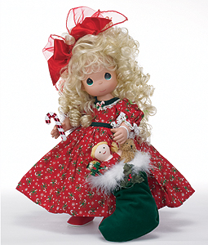

Yanina Madyniak

There's a little house in the large green forest. A lot of beautiful flowers grow around the house. The grass is green. Birds sing merrily there. A small girl lives in this house. Her name is Kathy. She is pretty and kind. Her hair is blond, her eyes are blue. Her dress is yellow and shoes are red. Kathy loves animals very much. She always feed them. Her best friends are Fox Dino, Hare Limo, Squirrel Liz, Deer Mimi. They always help each other.
One day when the sun was shining Dino and Limo were playing with the ball. Liz was eating nuts. Kathy was playing the violin. And curious Mimi went to the forest to look for the best grass. He went and went and . . . suddenly he fell into the trap. He tried to get out of it but it was impossible. Poor Mimi started roaring. His friends heard his voice and came to help him. They took a long rope and tied it to the big tree. They pulled him out. Everybody was happy. In the evening Mimi drank lots of milk and promised Kathy not to go to the forest alone.

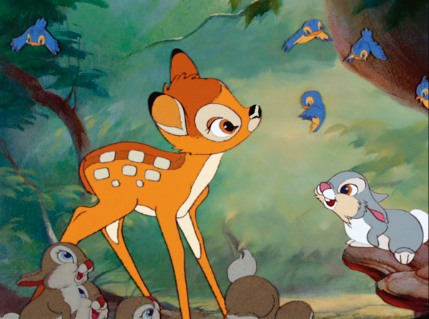

Yanina Madyniak

When birds start to sing their songs and the green grass begins to grow then comes a beautiful season called spring. In this season animals wake up from their deep sleep and plants start to grow and blossom. All inhabitants of the forest are still and quiet. But today the news is spread across the forest: the oak has fallen ill. All animals are coming to the Oak and they are making a noise around.
- What! What! What is that! - cries the Crow.
- Qu-u-u-ietly-y-y!!! Stop, animals! Our friend Oak is ill, but he drinks lime tea and eats cherry doughnuts. He will recover soon.
- Maybe, we should call for a doctor. What do you think? - says the Squirrel, that lives in a hollow of this oak.
- OK! It's a good opinion. What is a number of the Woodpecker? - asks the Hare.
- 073549 - says the Wolf.
Dzzzzz - ddzzzzzzz
- Hello! Doctor Woodpecker is speaking to you.
- Please, come to the sunny forest meadow, our friend Oak is ill.
- OK.
Bbryyyn - bbryyyn.
- Where is my patient? - asks the doctor.
- Come here, please, - says the Wolf.
- Hello! I am a doctor. How are you? I give you a small injection and you will be healthy. OK?
- OK, - says the Oak.
A - a - a -a!
- Doctor it hurts me. But... I feel better than in the morning.
- Well. You must take this medicine for 3 days.
Good-bye, - says the woodpecker and went away.
The Oak drank the medicine for 3 days and recovered soon.

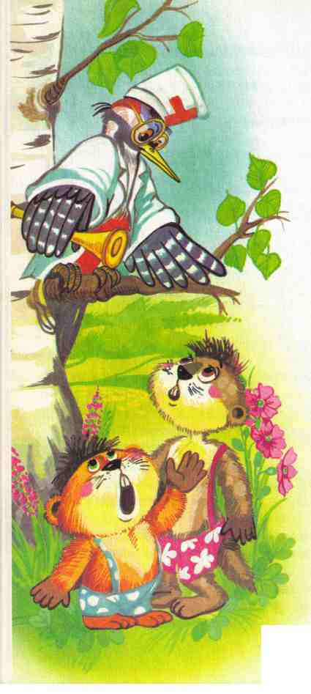
Yanina Madyniak

