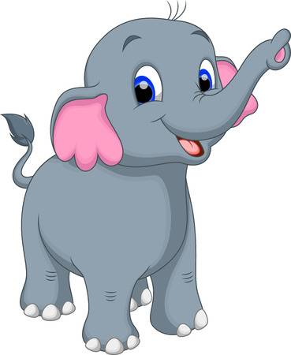 | An elephant
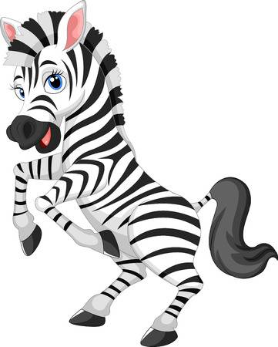 | A zebra
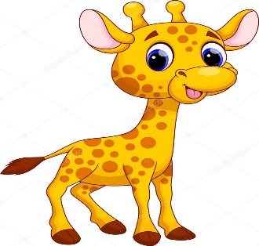 | A giraffe
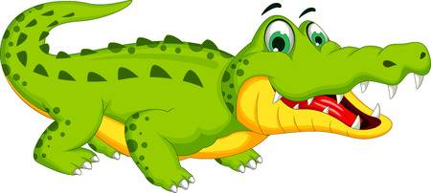 | A crocodile
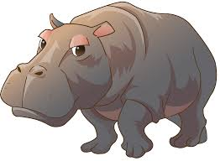 | A hippo
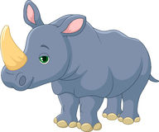 | A rhino
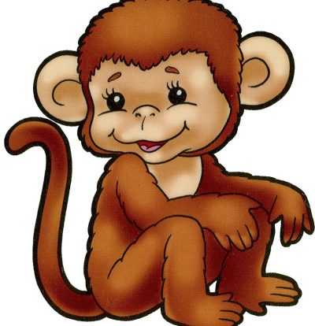 | A monkey
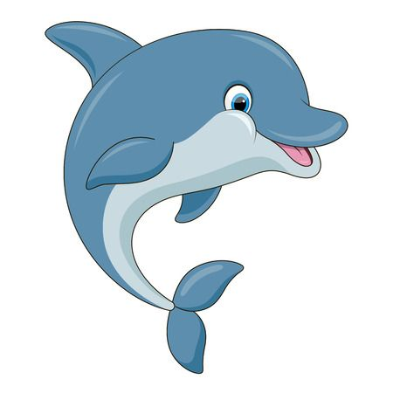 | A dolphin
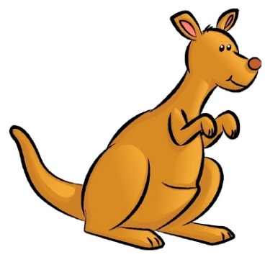 | A kangaroo
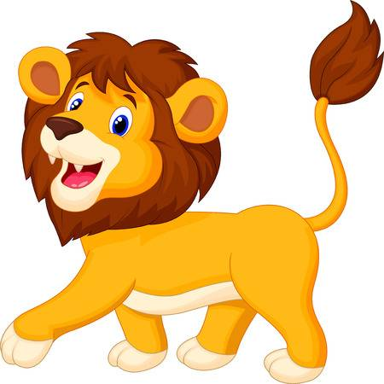 | A lion
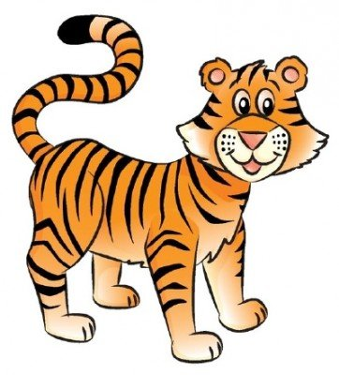 | A tiger
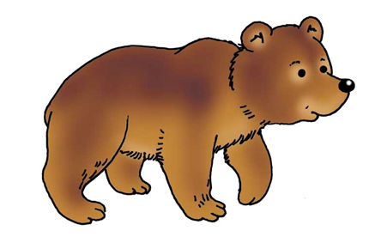 | A bear
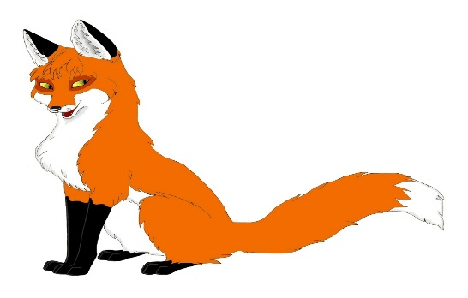 | A fox
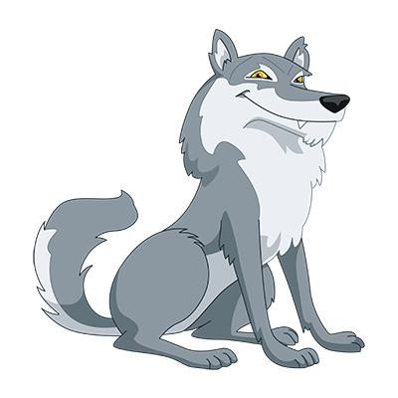 | A wolf
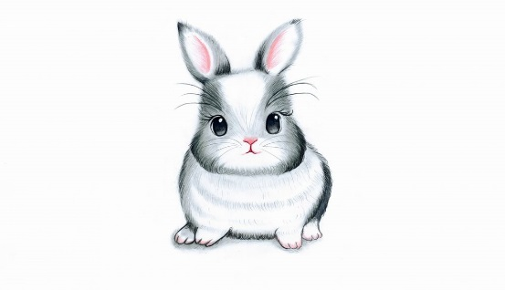 | A rabbit
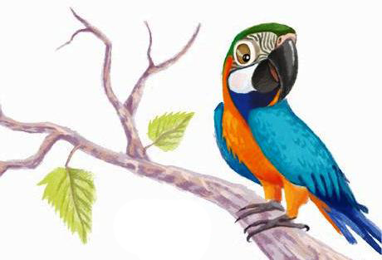 | A parrot
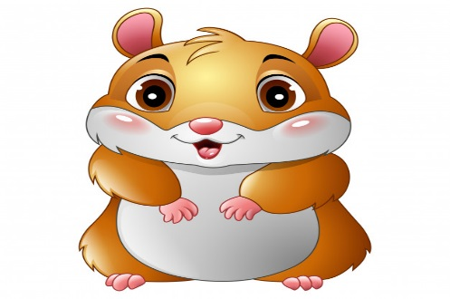 | A hamster
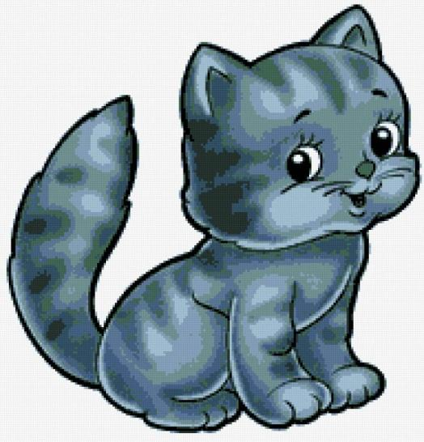 | A cat
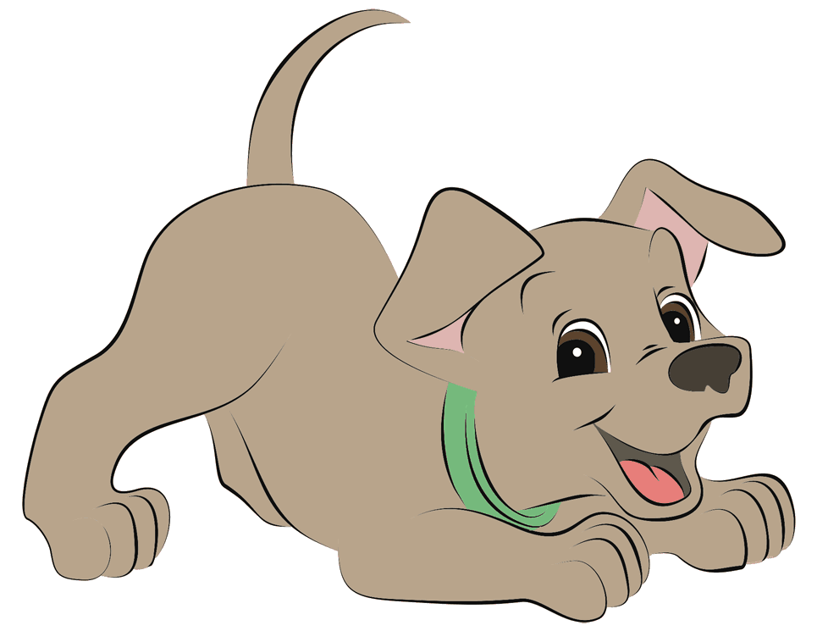 | A dog
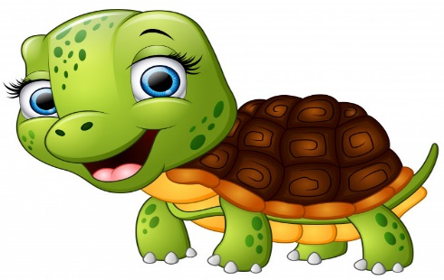 | A tortoise
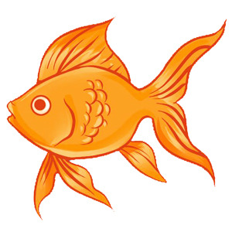 | A fish
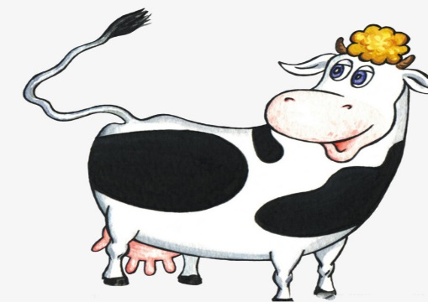 | A cow
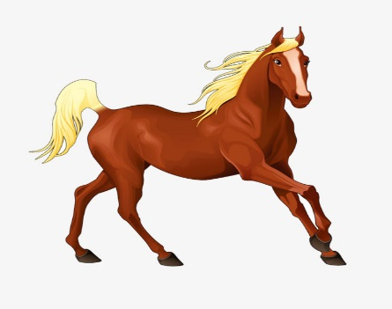 | A horse
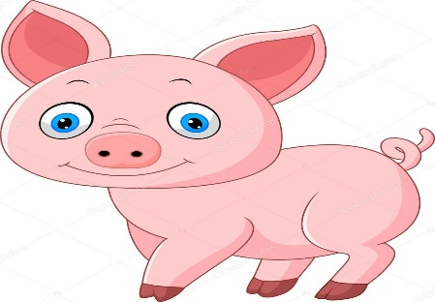 | A pig
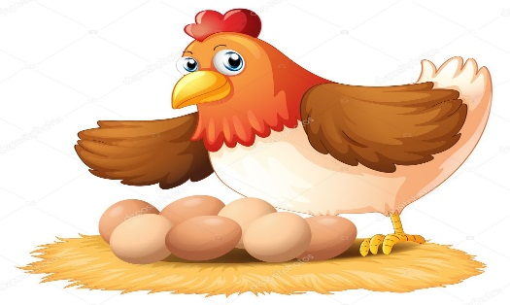 | A hen
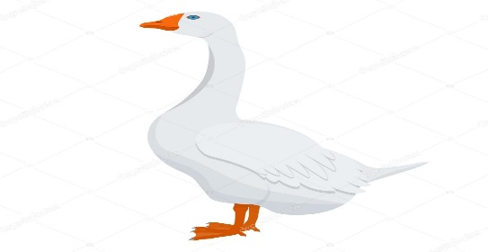 | A goose
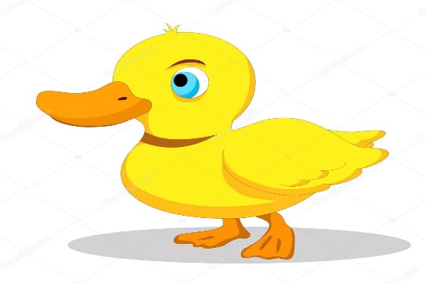 | A duck

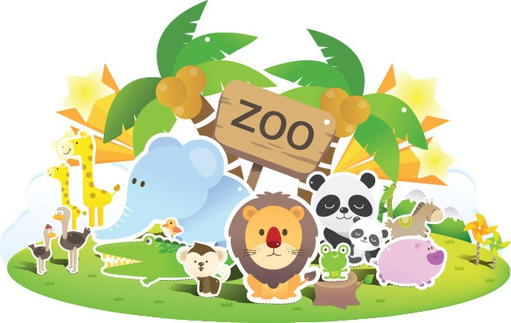
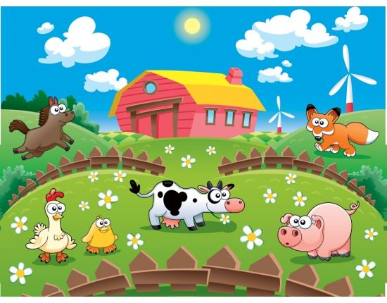

I have got a pet.  It is a …  Its name is …  It is …  It has got …  It can …  I like my … | I have got a pet.  It is a …  Its name is …  It is …  It has got …  It can …  I like my …
I have got a pet.  It is a …  Its name is …  It is …  It has got …  It can …  I like my … | I have got a pet.  It is a …  Its name is …  It is …  It has got …  It can …  I like my …
I have got a pet.  It is a …  Its name is …  It is …  It has got …  It can …  I like my … | I have got a pet.  It is a …  Its name is …  It is …  It has got …  It can …  I like my …
I have got a pet.  It is a …  Its name is …  It is …  It has got …  It can …  I like my … | I have got a pet.  It is a …  Its name is …  It is …  It has got …  It can …  I like my …
I have got a pet.  It is a …  Its name is …  It is …  It has got …  It can …  I like my … | I have got a pet.  It is a …  Its name is …  It is …  It has got …  It can …  I like my …

My pet
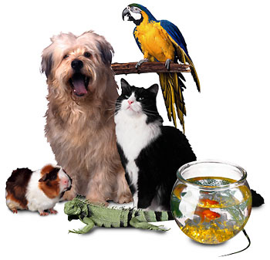

Is it true?
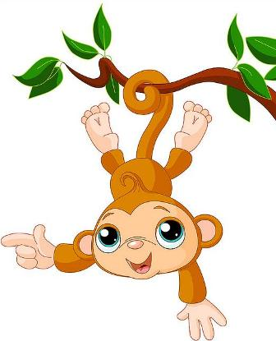

A giraffe has got a long neck. | A monkey can climb.
An elephant is a small animal. | A tiger has got a long body.
A wolf is white. | A rabbit has long ears.
A bear can swim. | A hippo has not got a tail.
A dolphin has got a tail. | A crocodile has got a big mouth.
A zebra has got short legs. | A cat cannot walk.
A tortoise is black. | A horse can jump.
A parrot can talk. | A pig has got two big eyes.

Animals and pets
