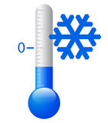 | It is cold.
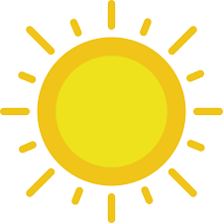 | It is hot.
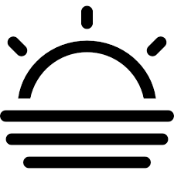 | It is foggy.
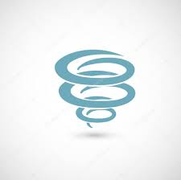 | It is windy.
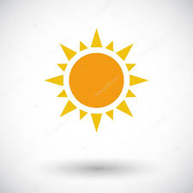 | It is sunny.
 | It is cloudy.
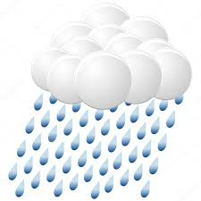 | It is rainy.
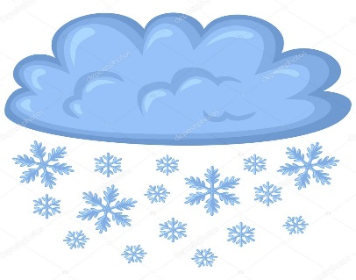 | It is snowy.
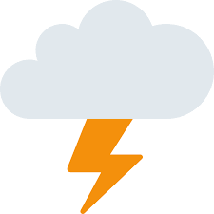 | It is stormy.

SUMMER
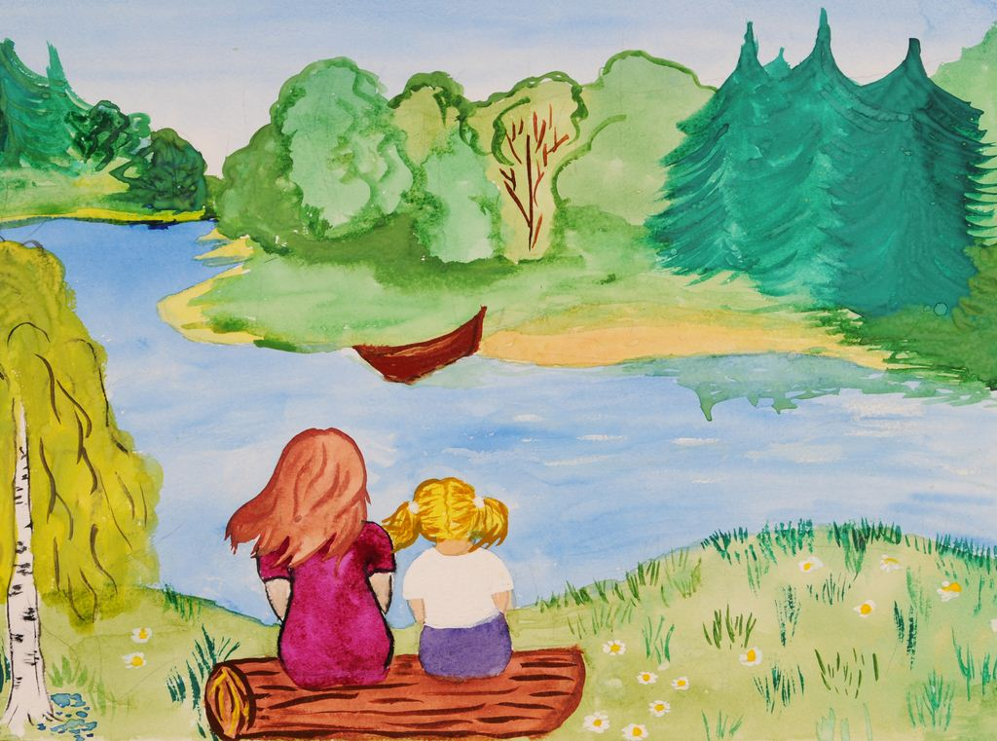

AUTUMN
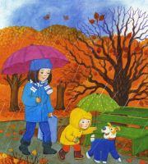
SPRING
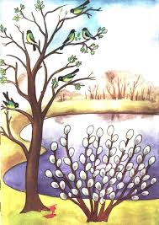

WINTER
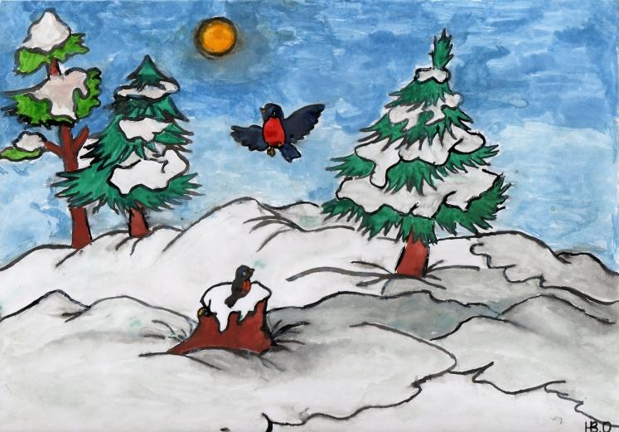

WEATHER
AND
CLOTHES
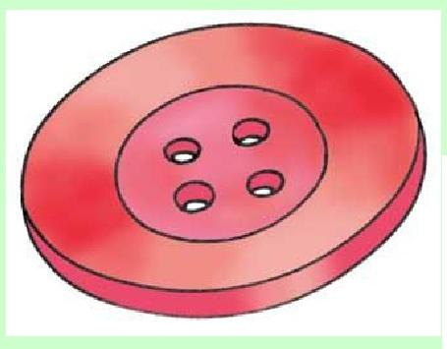

RIDDLES
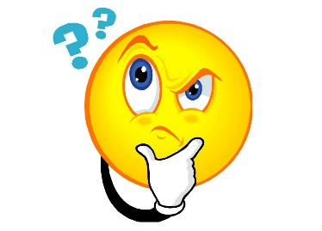

This is the season  when mornings are dark,  And birds do not sing  In the forest and park.  This is the season  When children ski,  And Santa Claus brings  The New Year Tree. | This is the season  When snowdrops bloom,  When nobody likes  To be in the room.  This is the season  When birds make their nests.  This is the season  We like the best.
This is the season  When fruit is sweet.  This is the season  When school friends meet.  When noisy and gay  To school they run.  With their books and bags  And brown in the sun. | This is the season  When nights are short,  When children are full  Of fun and sport.  Playing, swimming  All the day  With a happy song  On a sunny day.

My favourite season  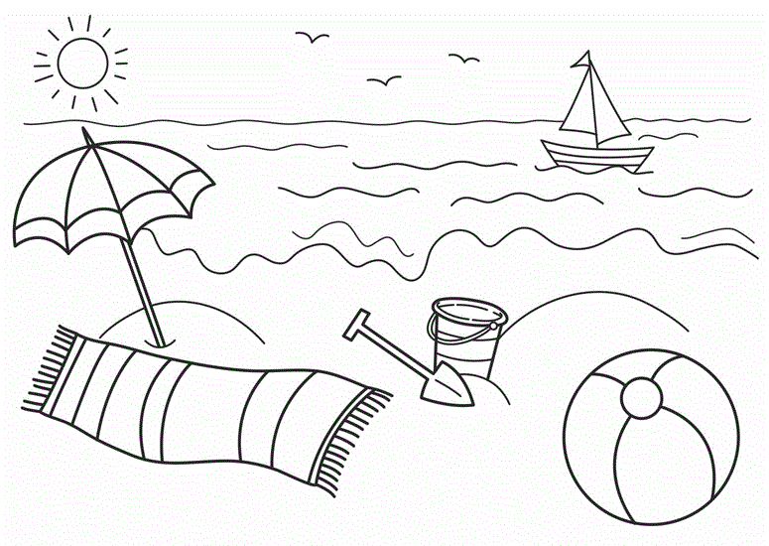 | My favourite season  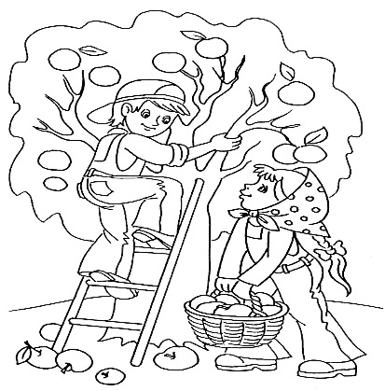
My favourite season  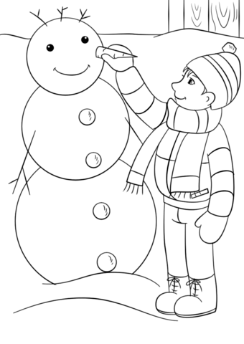 | My favourite season  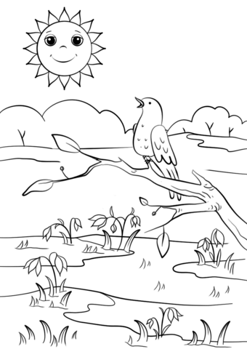
I am  wearing … | 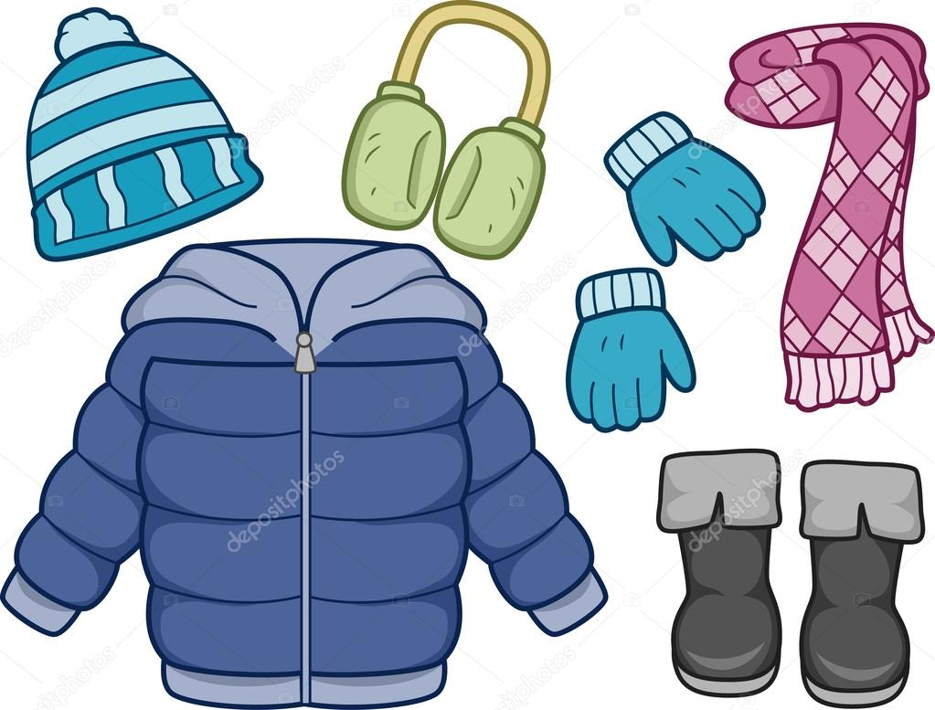
I am  wearing … | 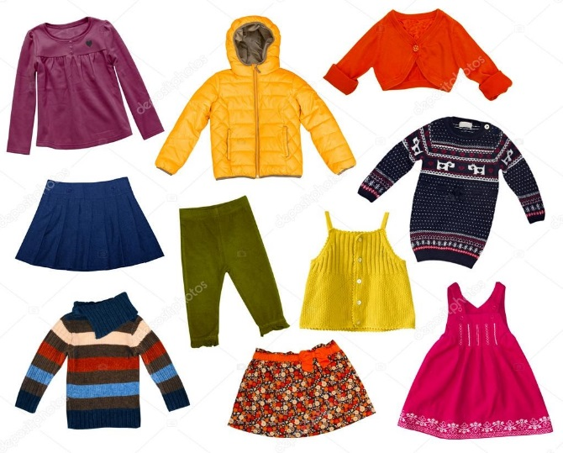
I am  wearing … | 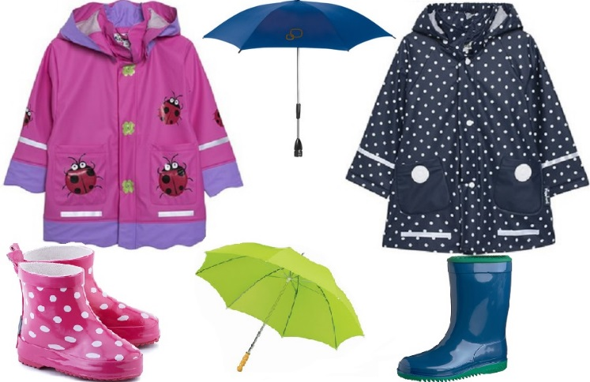
I am  wearing … | 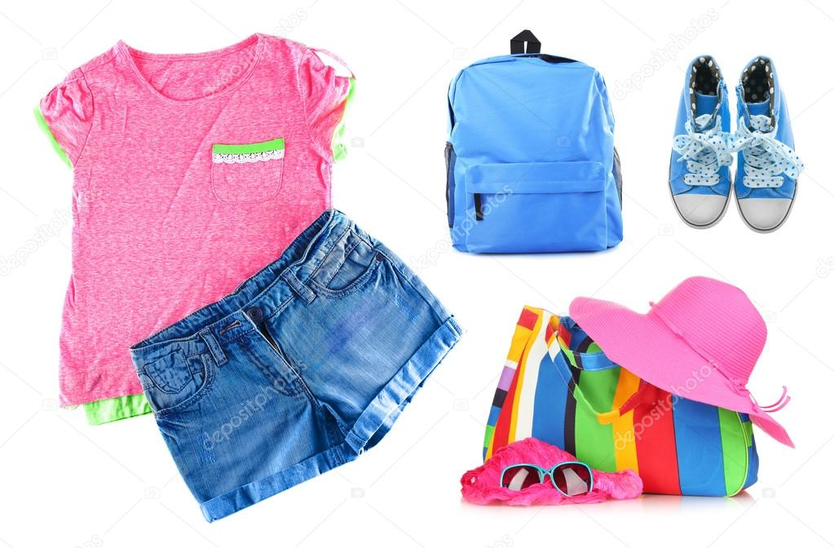

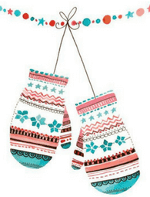 Rhyme
Three little kittens
They lost their mittens
And they began to cry,
Oh, mother dear,
We greatly fear
Our mittens we have lost
Lost your mittens
You naughty kittens!
Then you shall have no pie!
Miew, miew, miew,
No, you shall have no pie!

