There is a person in the world
Who takes care of me, who always helps.
She meets me always with a smile
And cherish as a little child.

This person is the busiest of all,
She cooks and cleans and bakes the rolls.
Besides she teaches children at school,
She is so kind and smart and cool.

I love this person the best of all.
I wish her health and pray for it God.
I often give her presents with my father.
I think you guess - this is my mother.

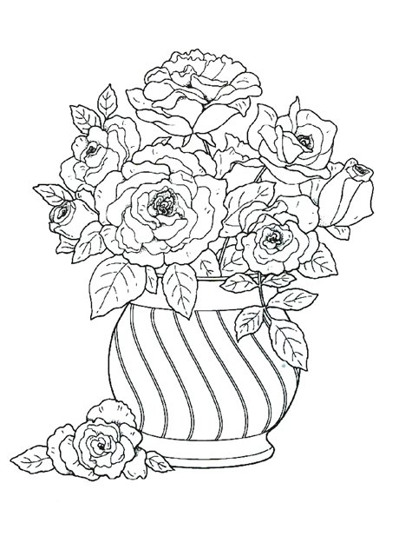
Prepared by Yulia Tatsynets

